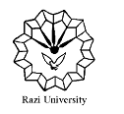
Razi University
Faculty of Chemistry

Department of physical chemistry
MSC. Seminar
Surfac Enhanced Raman Spectroscopy
SERS
Supervisor:
Dr.Hamid Reza Rafiee
Presented by:
Nasrin safari
1400/9/17
9:30AM
http://vc5.razi.ac.ir/rgt83ff8vr5g

