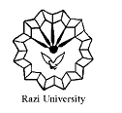

**Razi University**

**Faculty of Chemistry**

**Department of Analytical Chemistry**

**Ph.D. Seminar**

**Nanozymes: Classiﬁcation, Catalytic Mechanisms, Activity regulation, and Applications**

**Presented by:**

***Mohanna Ezati***

**Supervisor:**

***Prof. Mojtaba Shamsipuor***

**Advisor:**

***Dr. Ali Barati***

**Tuesday, 7 Dec. 2021**

**Time: 13:30 PM**

**Link:** http://vc5.razi.ac.ir/r5g15zki5oi0/