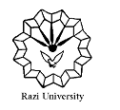
Razi University
Faculty of Chemistry
Department of Nanochemistry

Ph.D. Seminar
Hollow metal-organic frameworks:
Synthesis and applications

Presented by:
Elham Jalilian
Supervisor:
Dr. Mohammad Jafarzadeh

Monday, 13 Dec. 2021
Time: 11:30 AM

Link: https://vc5.razi.ac.ir/rqfbiynyylv4

