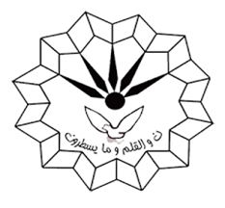

**Ph.D Seminar**

**Department of Organic Chemistry**

**Faculty of Chemistry**

**Razi University**

**Presented by:**

**Saeed Askari**

**Supervisor*:***

**Prof. Mohammad Mehdi Khodaei**

**Dr. Mohammad Jafarzadeh**

**Tuesday**

**2021 October 12**

**Time: 11 Am**

**post-synthetic modification (PSM) of metal-organic frameworks Toward Applications**