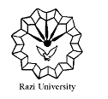

**Razi University**

**Faculty of Chemistry**

**Department of Physical Chemistry**

**M. S. C Seminar**

***Ionic Liquids Applications***

Supervisor:

**Dr. Hamid Reza Rafiee**

Presented by:

Zahra Akbari

2021 July 10, Saturday

09:30 AM

**http://vc5.razi.ac.ir/rsrfk5l4w0ov/**