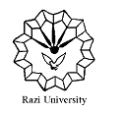

**Razi University**

**Faculty of Chemistry**

**Department of Applied Chemistry**

**Ph.D Seminar**

**Microbial desalination cell**

Supervisor:

**Dr. Ali Akbar Zinatizadeh**

**Dr. Sirus Zeinaddini**

Presented by:

**Fariba Oulad**

**Saturday**

October 24, 2020

2:00 PM

Faculty of Chemistry, Amphitheater