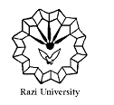

**Razi University**

**Faculty of Chemistry**

**Department of Analytical Chemistry**

**M. S. C Seminar**

**Application of metal-organic frameworks in sensors**

Supervisor:

**Dr. Fahimeh jalali**

Presented by:

**Hosna cheraghi**

2021 APril 7,wednesday

2:00 PM

Link : <https://vc5.razi.ac.ir/rnev4vhwywck/?session=breezbreez7wfecrzz8zfogsfo&proto=true>