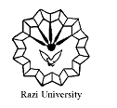

**Razi University**

**Faculty of Chemistry**

**Department of Physical Chemistry**

**M. S. C Seminar**

**Thermochromism**

Supervisor:

**Dr. Hamid Reza Rafiee**

Presented by:

**Soha Dastafshan**

2021 June 26, Saturday

10:00 AM

Link : http://vc5.razi.ac.ir/rc1hn306sphh/