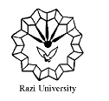

**Razi University**

**Faculty of Chemistry**

**Department of Analytical Chemistry**

**M. S. C Seminar**

**Supercapacitors**

**materials and Applications**

Supervisor:

**Dr. Fahimeh jalali**

Presented by:

**Yeganeh abasi**

2021 APril 7,wednesday

11 AM

Link : <https://vc5.razi.ac.ir/rbxqzbc1bj23/?session=breezbreezuno4crir2u9us5ba&proto=true>